REPUBLIC OF PHILIPPINES

**BICOL UNIVERSITY**

**POLANGUI**

Polangui, Albay

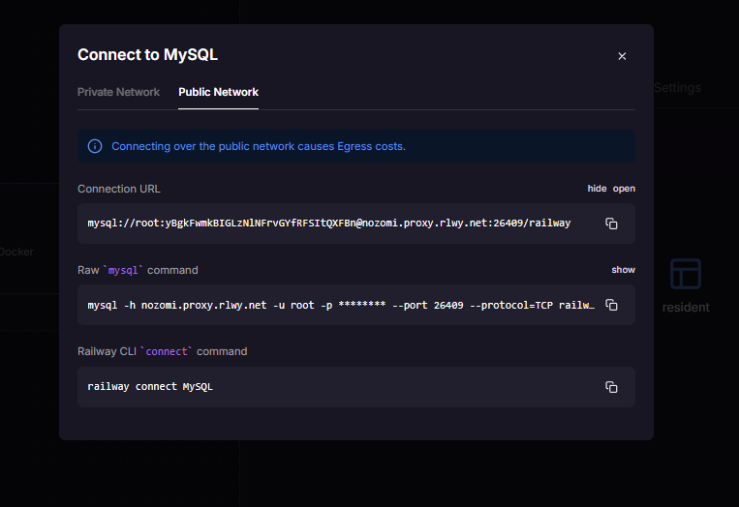**Documentation of cloud Deployment**

We used Railway as a cloud deployment platform to host a MySQL database and connect it to MySQL Workbench for local database management. First, we logged into our GitHub account and deployed a new project on Railway. After deployment, Railway provided the connection details for the MySQL database, including the connection URL, host, port, username (root), and password. The host was nozomi.proxy.rlwy.net with port 26409, and the root password was also provided.

Next, we opened MySQL Workbench and created a new connection. We entered the necessary details: the hostname and port, the username as "root", and the password that Railway had generated. After configuring these settings, We clicked on the "Test Connection" button. MySQL Workbench confirmed that the connection was successful, indicating that We had correctly configured the remote MySQL database connection.

This process allowed us to remotely access and manage our Railway-hosted MySQL database using MySQL Workbench on our local machine, which is essential for performing queries, managing data, and testing applications that rely on database connectivity.

